Open the "Foodmart_Data_Model.xlsx" worksheet that you saved on your desktop. This file was the finished product of your previous exercises. You should first complete all the other exercises and Quests before this one. If you just wrapped up the previous assignment, your view would probably look like the image below.

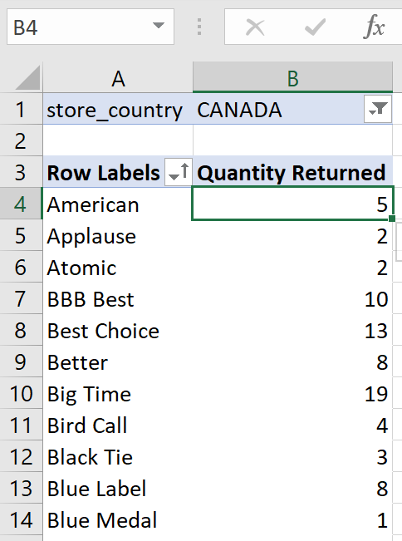 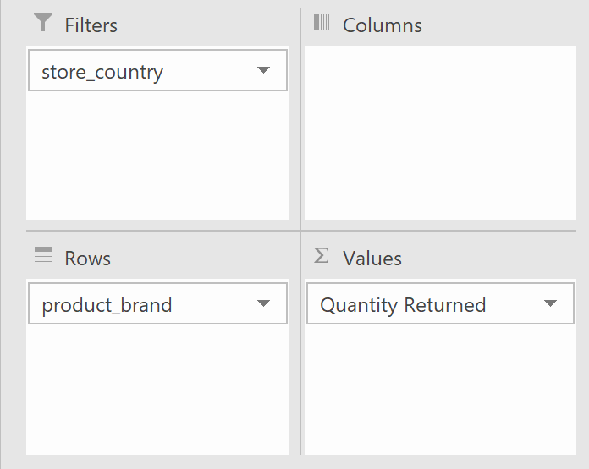



Clear the store_country filter out of there.

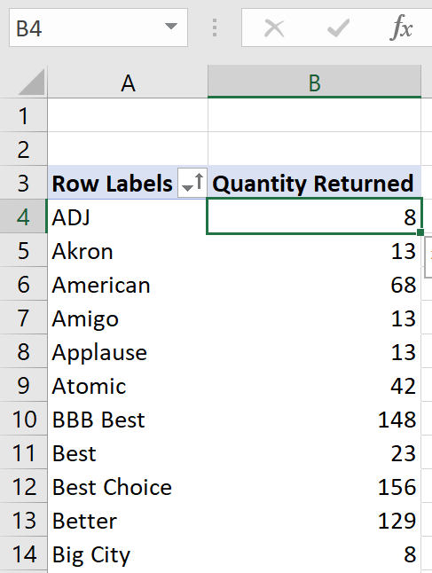 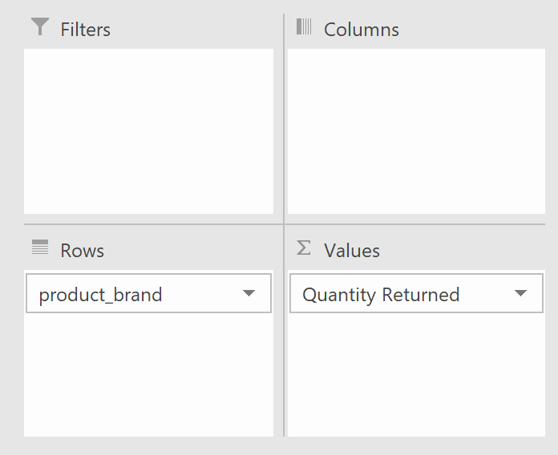



Pull into Values pane the Total_Quantity field.

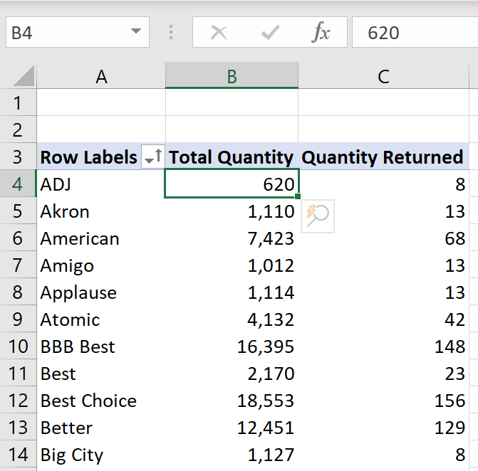 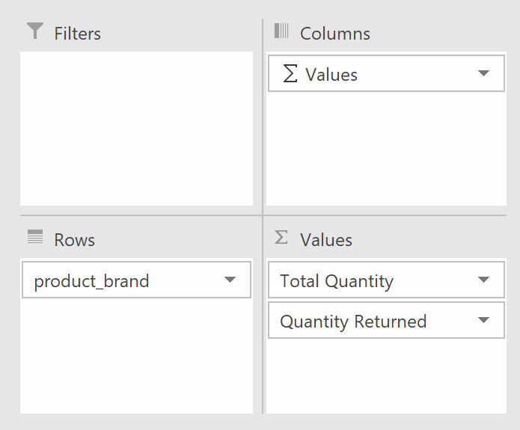



So now we have our two measures broken down into product brands.

Now let's create a new measure that will calculate the return rate. You already know how to create measures from previous assignments. Please review them if you forget the steps.

Give it a name Return Rate > save in Returns table > a description Ratio of quantity returned to total quantity. Type and Check the formula below. Format as Number > Percentage > with 1 decimal place. Then click OK.

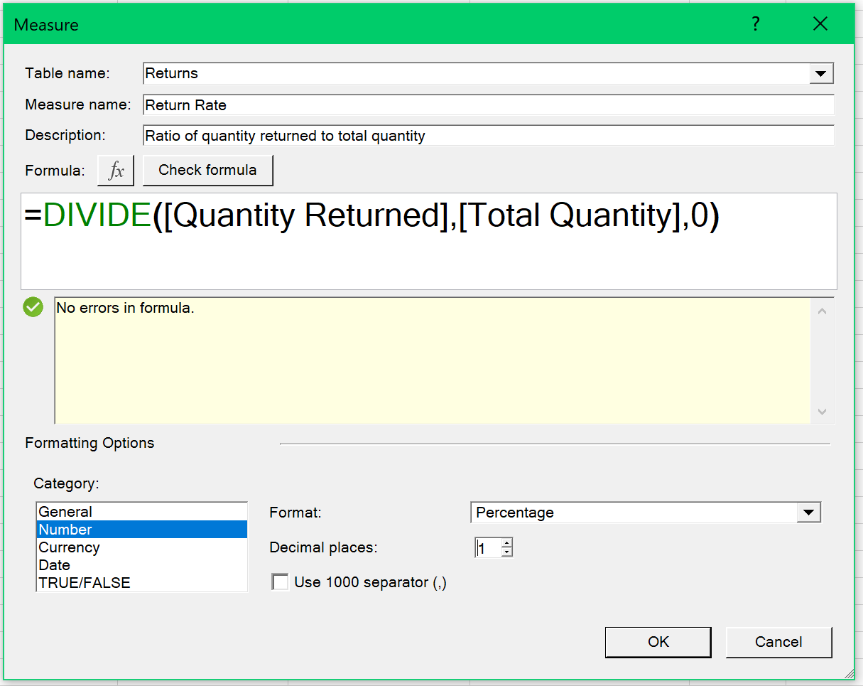

Your pivot table should look like the below:

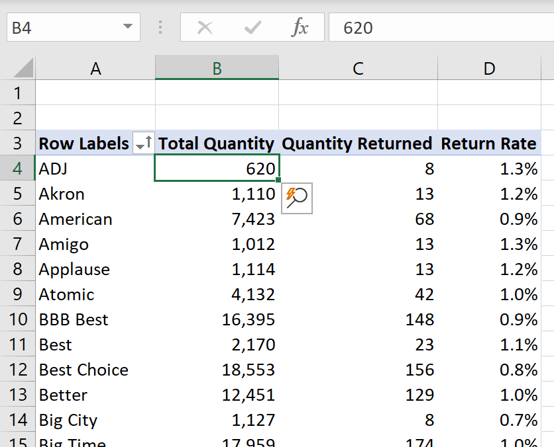 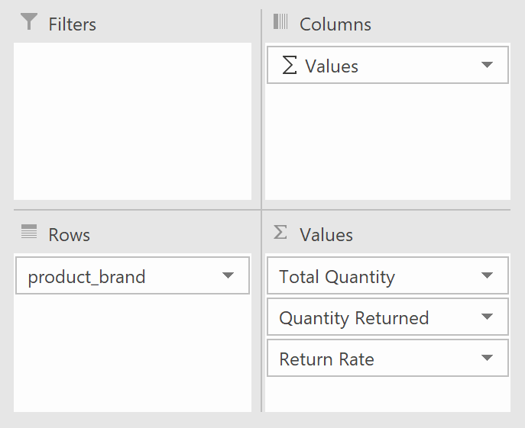

This new value will give us further insight into the data. For example, we will know if a particular product brand will generate a higher return rate. We can sort product brand descending by return rate. Sort by product brand and by return rate, then click OK.

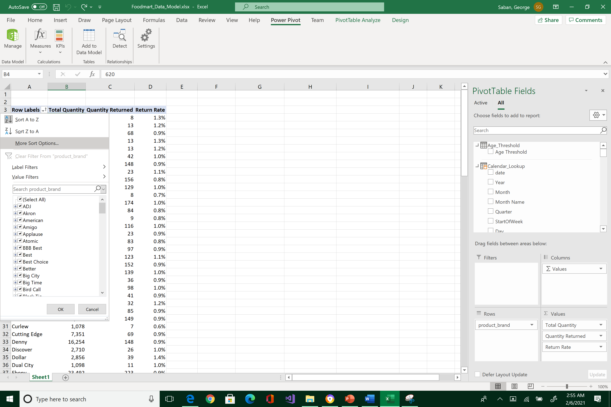 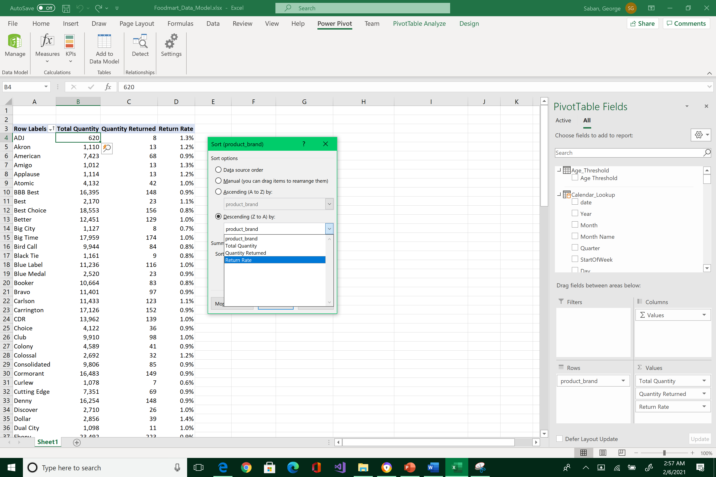



Note that King product has the highest return rate overall.

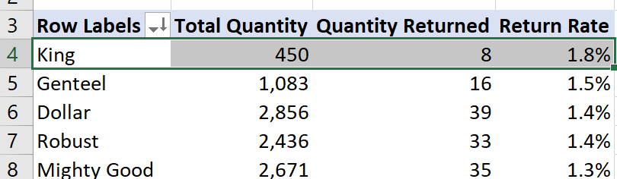

If you change the sort by ascending, you can see which ones have the lowest return rates. James Bay is the opposite end of the spectrum. They are only returned 0.3 percent.

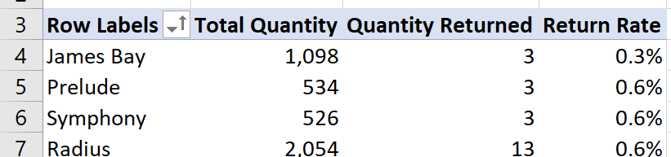



Note that this display and calculations are possible because of the relationship between the Product_Lookup table and Returns table. The filter flows down to returns table with no problem. If you use any fields from the Customer_Lookup as your filter for return, you will get awkward results because of the lack of relationship between the two tables. Filter does not flow up; it always trickles down. Furthermore, the product table is blind to the other filters in the other lookup table. That means that the only valid field to use in the values' pane had to be from the product table. That is why knowing your data model is critical when you are building these measures and filters.

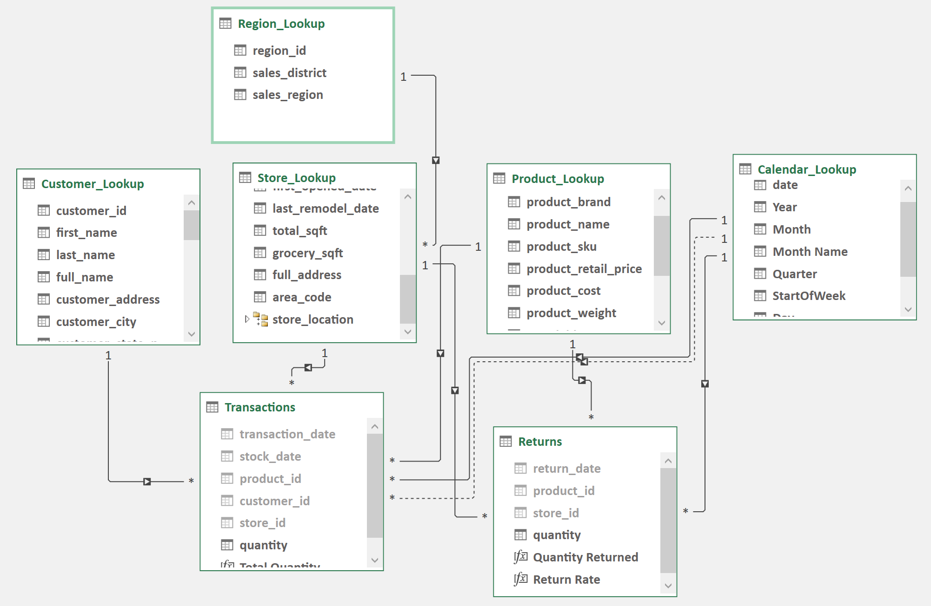



Remember to save early, save often, and backup your work.

What to submit? Please reposition your windows so that your screen would look like the image below.

1. Take a snapshot using Window's Snipping Tool.
2. Make sure the encircled items are included.
3. Submit to Canvas in PNG format.

Thank you!

